**SaaS Website**

**A Project Work Synopsis**

*Submitted in the partial fulfillment for the award of the degree of*

**BACHELOR OF ENGINEERING**

**IN**

**COMPUTER SCIENCE WITH SPECIALIZATION IN**

**ARTIFICIAL INTELLIGENCE AND MACHINE LEARNING**

**Submitted by:**

22BCC70109 Abhilakshya

22BCC70106 Muskaan Walia

22BCC70005 Jasanpreet Kaur

22BCC70054 Aastha Joshi

**Under the Supervision of:**

**Harun (E**



**CHANDIGARH UNIVERSITY, GHARUAN, MOHALI - 140413,**

**PUNJAB**

**September, 2022**

# Abstract

Our website is an innovative Software as a Service (SaaS) platform designed to transform the way artists, galleries, and art enthusiasts interact with and manage their creative endeavors. Rooted in the vibrant world of art, our website merges cutting-edge technology with a deep appreciation for artistic expression, offering a comprehensive suite of tools tailored to the needs of the modern art community.

At its core, our website empowers artists to showcase their work to a global audience through sleek and customizable online portfolios. By leveraging intuitive design and seamless integration with e-commerce functionalities, artists can effortlessly market and sell their creations directly from the platform. Through robust analytics and marketing insights, artists gain valuable data-driven strategies to enhance their visibility and reach.

# Table of Contents

|  |  |
| --- | --- |
| Title Page | i |
| Abstract | ii |
| 1.    Introduction |  |
| 1.1 Problem Definition |  |
| 1.2 Project Overview |  |
| 1.3 Hardware Specification |  |
| 1.4 Software Specification |  |
| 2.    Literature Survey |  |
| 2.1 Existing System |  |
| 2.2 Proposed System |  |
| 2.3 Literature Review Summary |  |
| 3.    Research Objective |  |
| 4.    Methodologies |  |
| 5.    Experimental Setup |  |
| 6.    Conclusion |  |
| 7.    Tentative Chapter Plan for the proposed work |  |
| Reference |  |

# 1. INTRODUCTION

## 1.1 Problem Definition

The world of art, with its boundless creativity and diverse expressions, has long been revered as a cornerstone of human culture. However, despite its profound impact, the art world faces several challenges that hinder accessibility, appreciation, and engagement among both creators and enthusiasts. Our website aims to confront these challenges head-on, revolutionizing the way art is experienced, shared, and celebrated.

## 1.2 Problem Overview

## 1.3 Hardware Specification

* Active internet connection
* An Intel Pentium 4 processor or later that's SSE3 capable
* A Server to Host the website

## 1.4 Software Specification

* Server Side:
  + Operating System
  + Server Hosting Software
* Client Side:
  + Windows 10 or later or Windows Server 2016 or later
  + Web-browser (Preferably latest version)

# 2. LITERATURE SURVEY

## 2.1 Existing System

While the existing system of art and design offers a plethora of tools and platforms to facilitate creativity, it is not without its downsides. One significant drawback is the fragmentation of software and services, which can lead to compatibility issues, workflow inefficiencies, and additional costs for users who must navigate multiple tools to accomplish their tasks. Moreover, the reliance on desktop-based software often restricts flexibility and collaboration, particularly for remote teams or freelancers who require seamless sharing and real-time editing capabilities. Given these challenges, there is a growing need for a more unified, accessible, and collaborative system that leverages cloud-based technologies, intuitive interfaces, and affordable pricing models to empower creatives of all levels to unleash their full potential and drive positive change in the art and design landscape.

## 2.2 Proposed System

With our website we are planning to create a platform that our users can use to create, edit and share their work on. We want to create a platform that can bring together different art pieces and artists in one place. Our website will be a place where users can showcase their work, look for feedback from like-minded people and get inspiration from by looking at other people’s works. We will also be incorporating graphic design elements into the website so that graphic designers can also showcase their works. The website will provide a connecting place for many artists and designers and may lead to much more collaborations in the future.

## 2.3 Literature Review Summary

|  |  |  |  |  |  |
| --- | --- | --- | --- | --- | --- |
| **Year and**  **Citation** | **Article/ Author** | **Title** | **place** | **Source** | **Contact** |
| March-April, 2018 | Baptista, R. and Shah, D | 3-Tier Website As a SAAS Model | In *InIC-CSOD-2018 Conference Proceedings* (p. 17) | IEEE | [**padwalpratham02@gmail.com**](mailto:padwalpratham02@gmail.com)  [**kumarinject@gmail.com**](mailto:kumarinject@gmail.com) |
| August, 2023 | L. Zhang, J. Bai and J. Xu | Optimal Allocation Strategy of Cloud Resources With Uncertain Supply and Demand for SaaS Providers | e National Social Science Fund of China | IEEE | [**zlc_041018@163.com**](mailto:zlc_041018@163.com) |
| 07 June 2021 | R. Cortesão, D. F. S. Fernandes, G. E. Soares, D. J. A. Clemente, P. J. A. Sebastião and L. S. Ferreira | Cloud-Based Implementation of a SON Radio Resources Planning System for Mobile Networks and Integration in SaaS Metric | 2COPELABS, Universidade Lusófona de Humanidades e Tecnologias, 1749-024 Lisbon, Portugal 3 Instituto de Engenharia e Tecnologias, Universidade Lusíada de Lisboa, 1349-001 Lisbon, Portugal | IEEE | rrlco@iscte-iul.pt |
| June 2019 | O. Pedreira, F. Silva-Coira, Á. S. Places, M. R. Luaces and L. G. Folgueira | Applying Feature-Oriented Software Development in SaaS Systems: Real Experience, Measurements, and Findings | 1Universidade da Coruña, Centro de Investigación CITIC, Facultade de Informática, A Coruña, Spain | GOOGLE SCHOLAR | oscar.pedreira@udc.es |
| 2010 | M. Boniface et al | Platform-as-a-Service Architecture for Real-Time Quality of Service Management in Clouds, | Barcelona, Spain | SCI-HUB | **DOI:-**[10.1109/ICIW.2010.91](https://doi.org/10.1109/ICIW.2010.91) |
| November 2019 | Shin NAKAJIMA | Model-Checking Verification for Reliable Web Service | Hosei University and PRESTO, JST | SCI-HUB | nkjm@i.hosei.ac.jp |
| 2019 | M. Godse and S. Mulik | An Approach for Selecting Software-as-a-Service (SaaS) Product | EEE International Conference on Cloud Computing, Bangalore, India, 2009 | GOOGLE SCHOLAR | 10.1109/CLOUD.2009.74. |

# 3. OBJECTIVES

# 4. METHODOLOGY

Initially user will be registering to our application using his/ her contact no. and email. Users will be able to then access the different features of the website. The users will also be able to upload their own works and showcase them on them website. The users will be able to directly converse with the owners of the original works in the future. The website will also be able to:

* To store all the data, we will be using the MongoDB database. The database will store all information related to the users and their files that are uploaded on the database.
* Whenever a user wants to create a new file, he/she can open the editor or upload a file of their own and get straight to work. All tools related to painting and wireframing will be available in the same window to help the users be accustomed to the website irrespective of their work.

**5. EXPERIMENTAL SETUP**

* Index.html

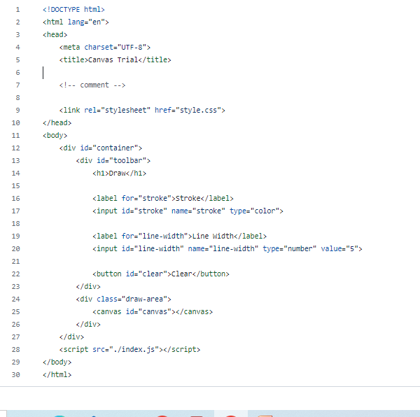

* Index.js

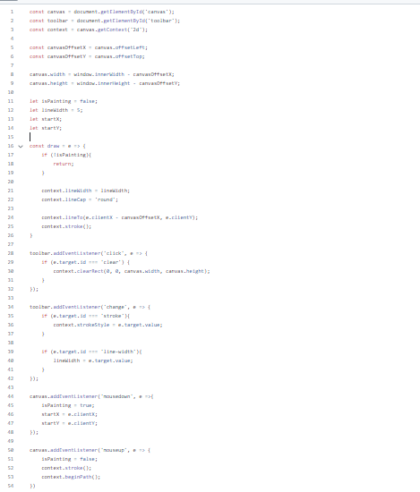

* Style.css

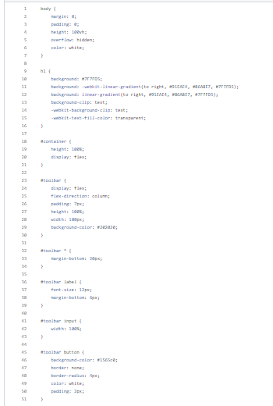

* Result

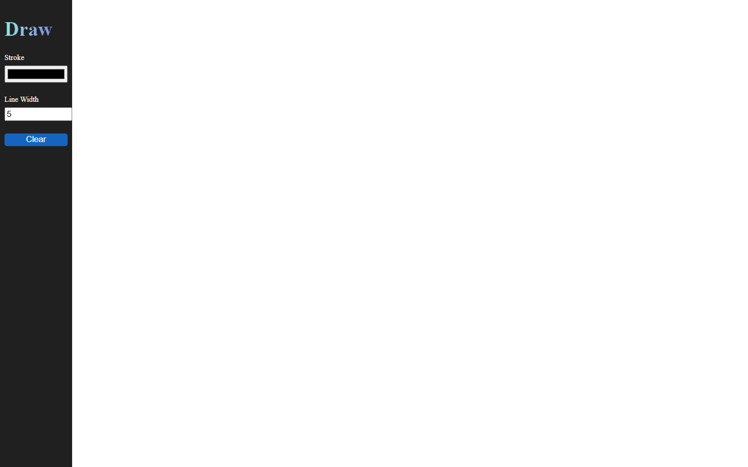

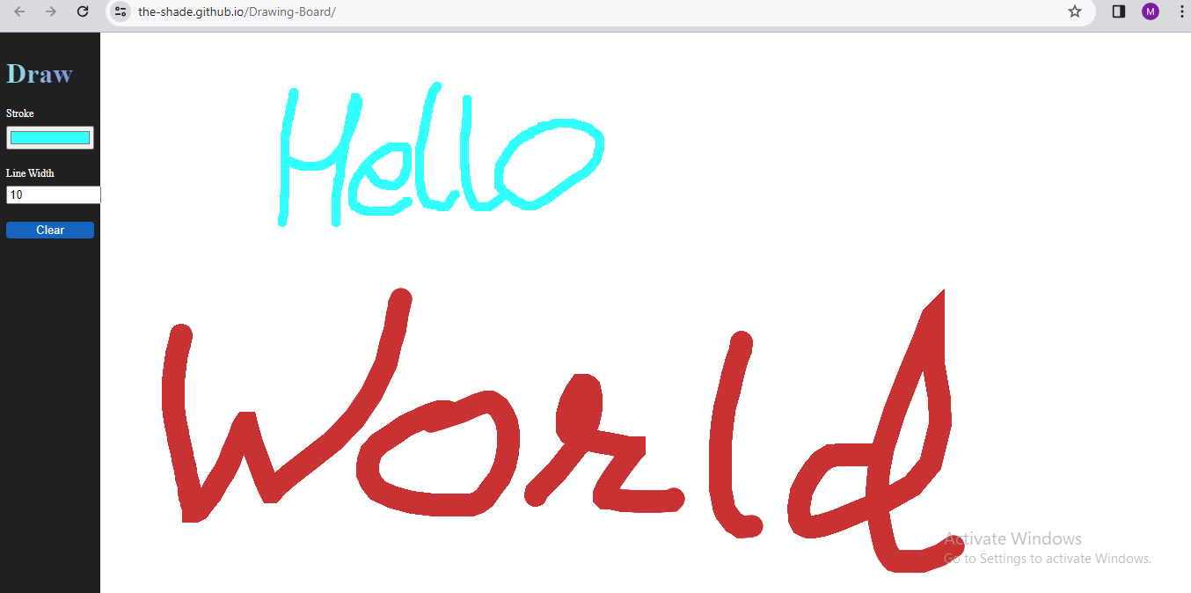

# 6. CONCLUSION AND FUTURE SCOPE

In conclusion, In summary, the creation of the SaaS-based online sketching and painting program marks a turning point in the blending of technology and creative expression. This ground-breaking project aims to reshape the field of digital creativity by placing a major focus on accessibility, collaboration, and ongoing innovation.

The program makes sure that traditional boundaries do not impede artistic instruments by implementing the Software as a Service model. Digital art is becoming more accessible, enabling a global community of artists to freely create, collaborate, and share their thoughts.

With its user-friendly drawing tools and real-time collaboration features, the app's design is versatile enough to meet the wide range of needs of artists.

With the completion of this project, a new chapter in the history of digital art begins. The SaaS-powered web-based drawing and painting application is proof of the endless possibilities that arise when creativity and technology meet. It challenges creators to set out on a path of exploration, cooperation, and ongoing development in order to mold the future of digital art in a worldwide community that is inclusive and linked.

Some of the features that we can add to the project in the future are:

* **Feedback option:**

Implementing a feedback option in your web-based drawing/paint web app is a valuable feature that can enhance user engagement and provide insights for continuous improvement.

* **AI Integration for Enhancing Creativity:**

  The implementation of an Artificial Intelligence (AI) could play a significant role in suggesting creative ideas, providing intelligent assistance in drawing, and automating certain repetitive tasks to streamline the artistic process.

* **Performance Analytics:**

Implement basic analytics to gather insights on user behavior, helping to identify popular features and areas for improvement.

## 7. TENTATIVE CHAPTER PLAN FOR THE PROPOSED WORK

**CHAPTER 1: INTRODUCTION**

**CHAPTER 2: LITERATURE REVIEW**

**CHAPTER 3: OBJECTIVE**

**CHAPTER 4: METHODOLOGIES**

**CHAPTER 5: EXPERIMENTAL SETUP**

**CHAPTER 6: CONCLUSION AND FUTURE SCOPE**

## REFERENCES

[1]